Lab 02a – Manage Subscriptions and RBAC

Task 1–4: Execution Notes

Task 1 – Create and configure a Management Group
First, we navigate to Management Groups in the Azure Portal.
In this case, access is done directly using the central search bar in the portal.
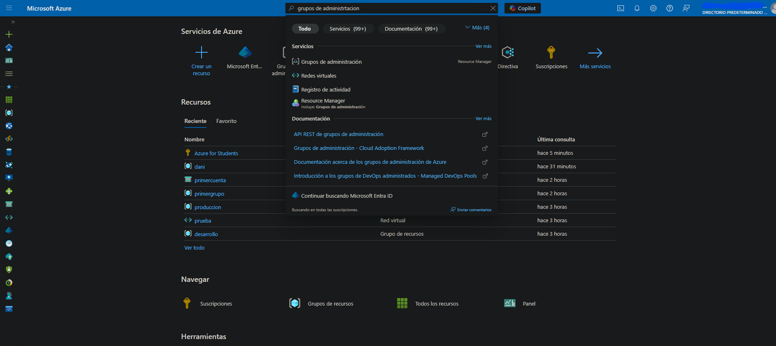
Once inside, we create a new Management Group with the following configuration:
- Management Group ID: az104-mg1
- Display Name: az104-mg1
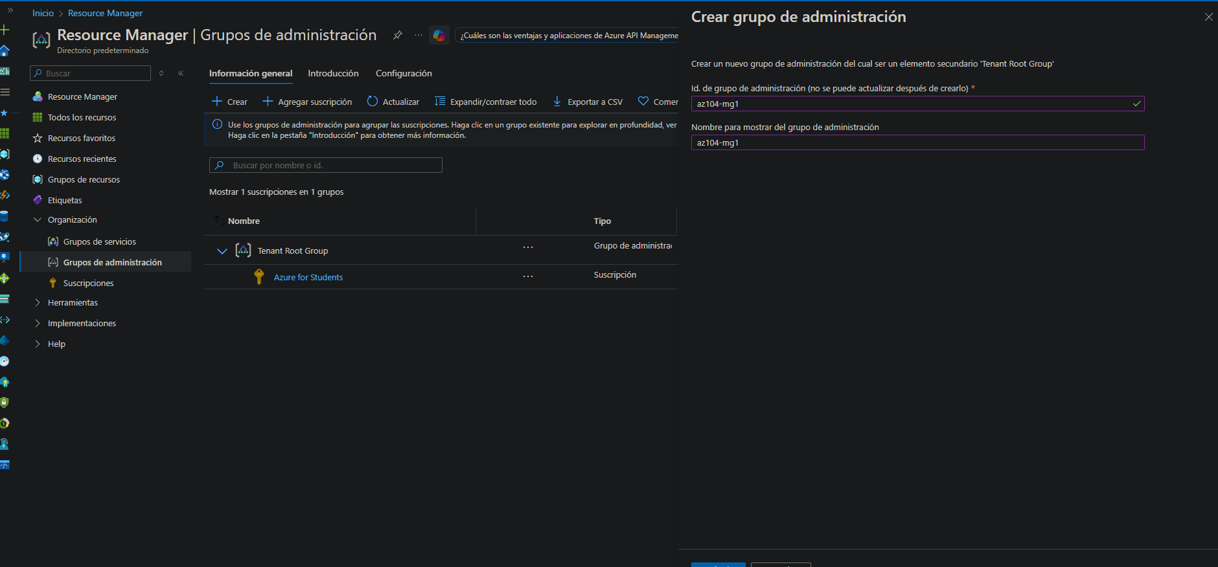
After completing the required fields, we select Create.
Azure displays a confirmation notification indicating that the update was successful.
It is important to note that the creation process may take a few moments to complete.
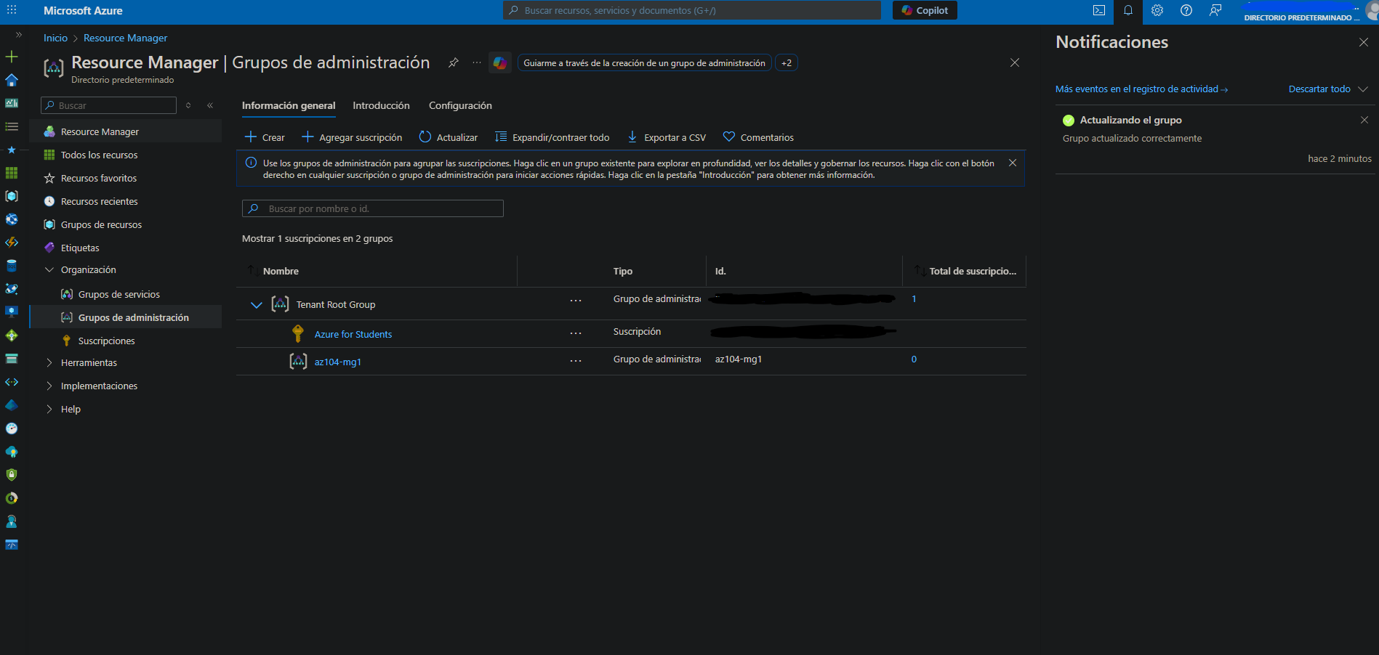

Task 2 – Assign a built-in RBAC role
Inside the newly created Management Group, we navigate to Access Control (IAM) and select Add → Add role assignment.
We search for and select the Virtual Machine Contributor role.
This role allows users to manage virtual machines without granting access to the operating system or related networking and storage resources, making it appropriate for a Help Desk team.
Next, we select the Help Desk team group as the assignee.
This group was created beforehand specifically for this lab.
Before completing the assignment, Azure presents a summary showing:
- The selected role
- The assignment scope (Management Group az104-mg1)
- The target members (Help Desk group)
Once the role assignment is created, we verify it under Access Control (IAM) → Role assignments, confirming that the Help Desk group now has the Virtual Machine Contributor role.

Task 3 – Create a custom RBAC role
Next, we create a custom RBAC role to better align with the principle of least privilege.
From Access Control (IAM), we select Add → Custom role.
The role is configured as follows:
- Role name: Custom Support Request
- Description: A custom contributor role for support requests
- Baseline permissions: Clone role
- Cloned role: Support Request Contributor
After cloning the role, we customize its permissions.
Under Exclude permissions, we search for and select:
- Other: Register Support Resource Provider
This permission is added as a NotAction, ensuring that the Help Desk team cannot register Azure resource providers.
This design ensures that the Help Desk team:
- Can create and manage support tickets
- Can view basic information
- Cannot enable new Azure services or providers
We then confirm that the assignable scope is correctly set to the Management Group az104-mg1.
Before finalizing the creation, we review the resulting JSON definition to validate the configured Actions, NotActions, and scopes.
After creation, we verify that the custom role appears under Access Control (IAM) with the expected configuration.

Task 4 – Review role changes using Activity Log
After completing the previous tasks, we navigate to the Activity Log of the Management Group az104-mg1.
The Activity Log shows:
- Role assignments
- Creation of the custom RBAC role
- Other administrative actions performed during the lab
This confirms that Azure tracks and audits RBAC-related changes at the management group level.

Cleanup – Remove the Management Group
To complete the lab and avoid unnecessary resource usage, the Management Group is removed.
Before deletion, we ensure that:
- No subscriptions are associated with the Management Group
- No dependent resources exist
The Management Group can be deleted using:
- Azure Portal: Management Group → Overview → Delete
- Azure PowerShell:
Remove-AzManagementGroup -GroupName az104-mg1
After deletion, we wait for the operation to complete, refresh the portal, and confirm that the Management Group has been successfully removed.

Next step
The remaining work consists of:
- Adding screenshots aligned with each task
- Writing the introduction and business scenario (roleplay)
- Creating a concise LinkedIn post based on this lab
When you are ready, I can draft the Introduction + Scenario section, which will serve as the foundation for the final README and the LinkedIn publication.

